1. 
2. A diagram of a computer

   Description automatically generated  
   As per this diagram, we will create a tree which will point to two blobs (files) file1.txt and file2.txt with SHA1 b7aec5 & 4400aa respectively.  
   **NOTE**: The file (blob) name will be specified inside the Tree. We had discussed that Blob doesn’t store file name.  
   The file permission for blob will be 100644 as per the following:  
   A black text on a white background

   Description automatically generated
3. Following will be the content of the tree as per the above structure.   
   A close-up of a number

   Description automatically generated **NOTE**: After the SHA1, there is TAB.
4. CommandA close-up of text

   Description automatically generated
5. **Linux Command**:  
   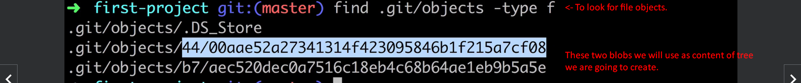
6. **Command Description**:  
   
7. A screenshot of a computer

   Description automatically generated
8. 
9. 